SWEDISH RORSTRAND PORCELAIN CERAMIC LAMP

Sweden, c. 1940

EA1645
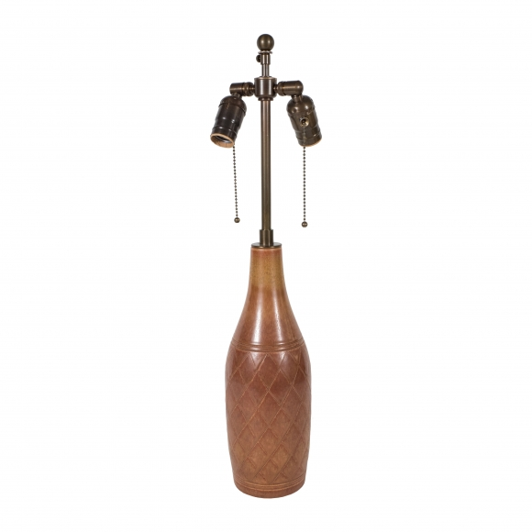
A Swedish Rorstrand porcelain ceramic Lamp. Base with incised cross hatched decoration under a brown glaze, designed by Gunnar Nyland.
H: 24 Diam: 5 in.

