# LARGE ITALIAN MURANO SOMMERSO LAMP WITH BLUE AND GREEN GLASS

## Italy, c. 1960

### EA2467

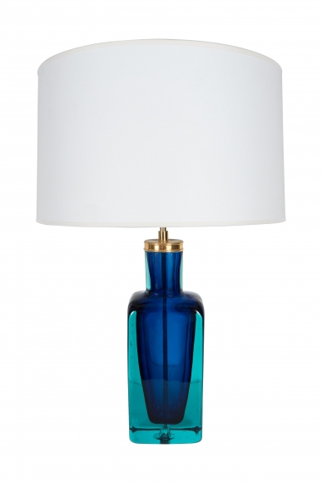

H: 27 W: 5.5 D: 4.25 in.