JEAN GRISONI SILVER LINK BRACELET WITH MAARTEN BRUSH

France, Contemporary

c. 2014

CH-G 391

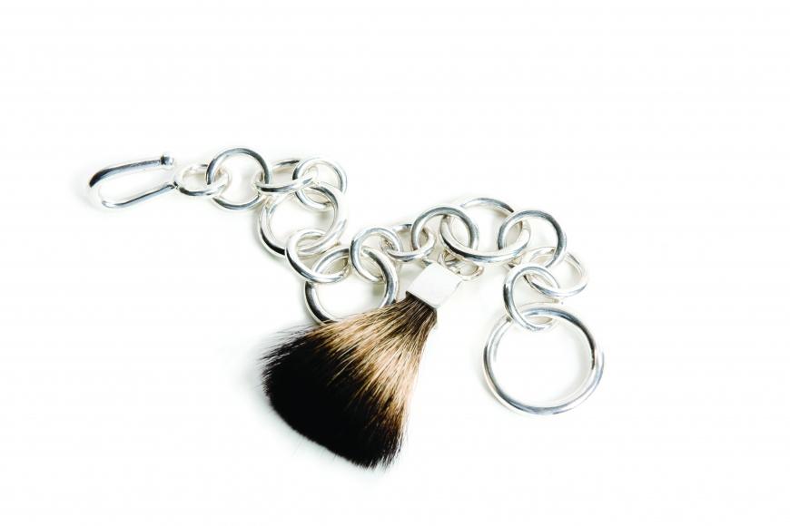

W: 1 L: 8 in.

